Gorge Grown Farmers’ Markets Vendor Currency Guidelines
The Gorge Grown Food Network uses several different tokens at all Farmers’ Markets. We accept debit cards, checks, and SNAP (food stamps) at the information booth for tokens. We offer a $5 SNAP match ($10 in Odell). Please read below for details about how to accept each token and voucher. Please remember:
- Always redeem your tokens at the info booth every week.
- If a new employee or friend is covering your booth, it is your responsibility to make sure they are aware of which tokens to accept.
- You will not be reimbursed for mistakenly accepted tokens.
- When no change is allowed for a token, please work with shoppers to even out their total or have the customer supplement tokens with cash.
- All vendors must track and report weekly gross sales for our records.
Currency | Details | Looks Like
Cash / Check | MANDATORY – all vendors  The easy one! You are not required to accept checks. Checks can be used at the info booth for $10 tokens.  CHANGE: OK in cash | 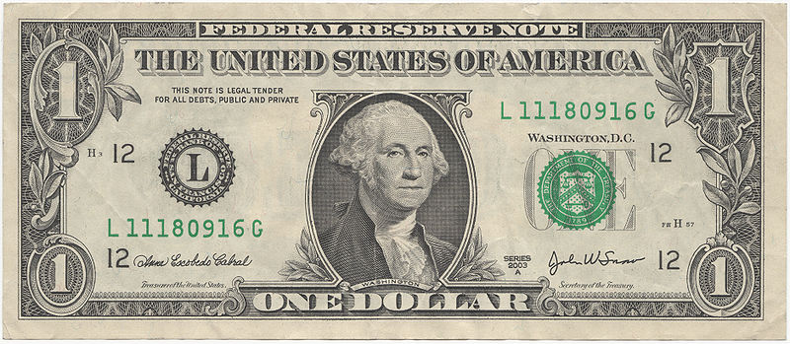
$10 GREEN Tokens | MANDATORY – all vendors  All vendors must accept the green $10 tokens. These tokens work like cash – a shopper receives them when using a debit card, check, or gift certificate at the info booth.  CHANGE: OK in cash | 
Veggie Prescription Program (Veggie Rx)  Checks | MANDATORY – all PRODUCE vendors  All PRODUCE vendors must accept the $2 Vegetable Prescription Program (Veggie Rx) Checks. For the purchase of whole fresh fruits and vegetables only. Please note expiration dates.  CHANGE: NO CHANGE GIVEN | 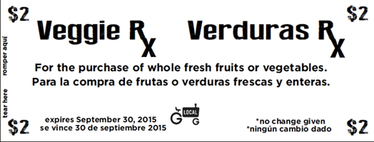
$2 RED Tokens | MANDATORY – all PRODUCE vendors  All PRODUCE vendors must accept the red $2 tokens. These are food stamp tokens – ONLY FOR USE ON FOOD & PRODUCE (fruit, veg, meat, dairy, bread, etc) and PREPARED FOOD THAT IS NOT HOT FOOD TO EAT ON SITE (pastries OK, sandwich not OK)  CHANGE: NO CHANGE GIVEN | 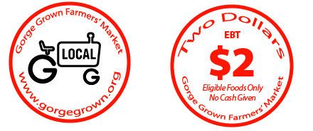
$1 BLUE Tokens | MANDATORY – all PRODUCE vendors  All PRODUCE vendors must accept the blue $1 tokens. These are incentive tokens for the food stamp match program. Treat exactly like the red $2 tokens.  CHANGE: NO CHANGE GIVEN | 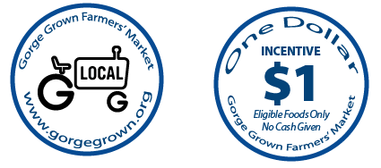
 | FLIP FOR MORE
FDNP & SFDNP Coupons | MANDATORY – all PRODUCE vendors  All PRODUCE vendors MUST register to accept the $3 SFDNP and $4 FDNP checks and display their WIC COUPONS WELCOME HERE sign at ALL markets. Market Managers will check for compliance. DO NOT accept checks until you are registered. DO NOT redeem at the info booth.  See the market manager to determine your eligibility  CHANGE: NO CHANGE GIVEN | 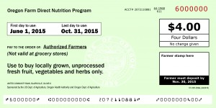 Note: Senior FDNP checks are blue. See below
WIC Coupons | VOLUNTARY – PRODUCE vendors  PRDODUCE vendors are not required, but are encouraged to also register to accept $10 WIC checks. Accepting these checks is more complicated. DO NOT accept checks until you are registered. DO NOT redeem at the info booth.  CHANGE: NO CHANGE GIVEN | 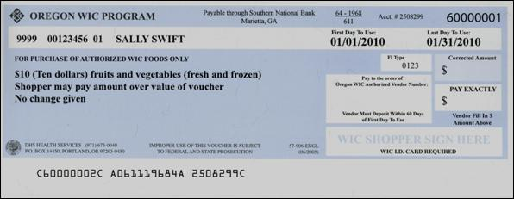
$2 ORANGE POP Club Tokens | MANDATORY – all PRODUCE vendors at Mercado del Valle and Mosier Farmers Market  Vendors must accept the Orange $2 token for fresh fruits and veggies only. These are incentive tokens given to kids 12 and under who join the Power of Produce (POP) Club.  CHANGE: NO CHANGE GIVEN | 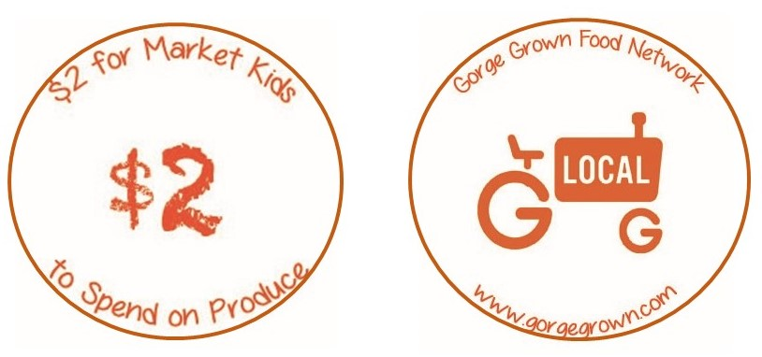
Market Money and Market Gift Certificates | DO NOT ACCEPT THESE. They need to be turned in at the info booth for $10 tokens. Please send shoppers to the info booth for this exchange and then they can proceed with their shopping.
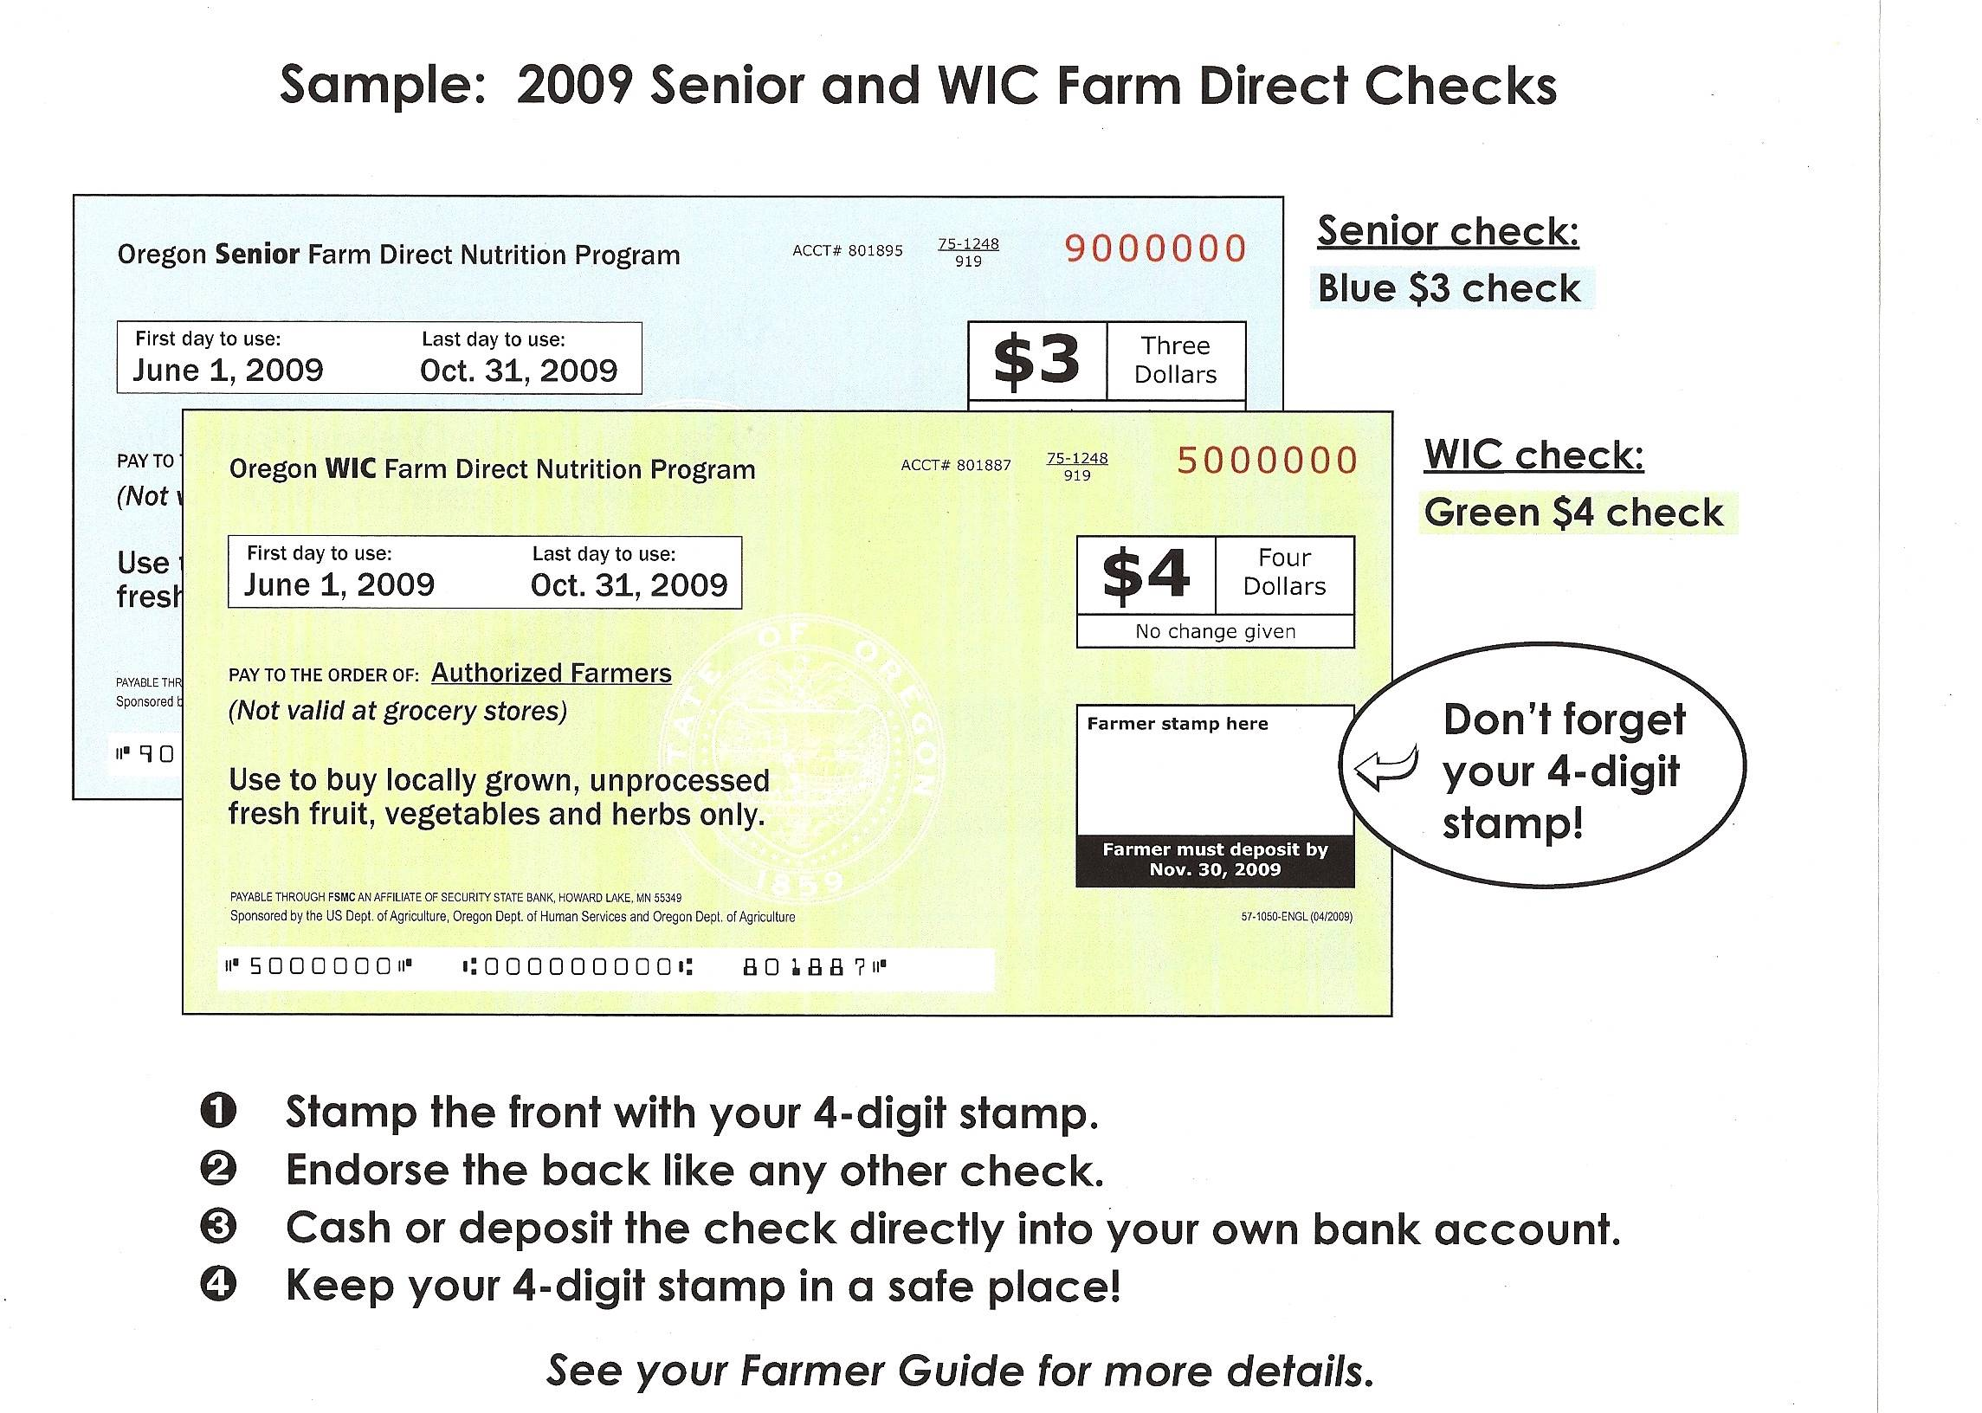

Please ask if you are not sure which tokens you can accept!

